Zimbogasana - Series 31 (All Levels – National Yoga Month: Partner Dance Flow)
Split the room into 2 – intermediate and beginners. Do a short flow, then a partner pose then dance around the mat to Bangles ‘Walk like an Egyptian’. Use National Yoga Month Playlist.
 | Warm Up
 | All Levels - Flow 1 | All Levels - Flow 2 | Intermediate - Flow 1 | Intermediate – Flow 2
 | Down Dog (walk to) | Down Dog (walk to) | Down Dog (float to) | Down Dog
 | Malasana | High Lunge | Malasana (then bind) | Shiva
 | Standing Stack | WIII | Flamingo | Baby Grasshopper
 | Tree Pose | Half Moon | Birds of Paradise | Revolved Dancer
 | 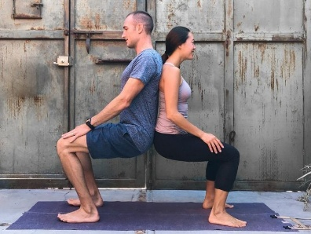 | 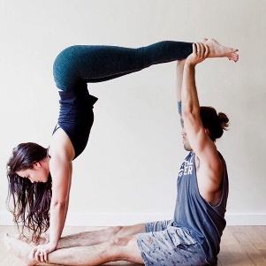 |  | 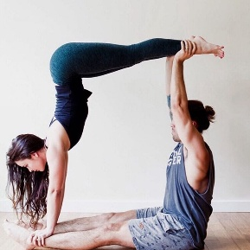
 | Dance around the mat | Dance around the mat | Dance around the mat | Dance around the mat
 | High Mountain to Chair | Mountain to High Lunge | Mountain to Pistol Squat | Mountain to High Lunge
 | Shoulder Stand | Revolved High Lunge | Shoulder Stand | Floating Rev H, Lunge
 | Bridge/Wheel (hips up) | WII | Bridge to Eagle Wheel | Bound Standing Splits
 | 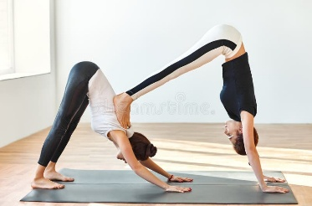 | 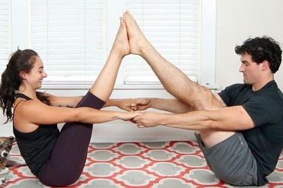 | 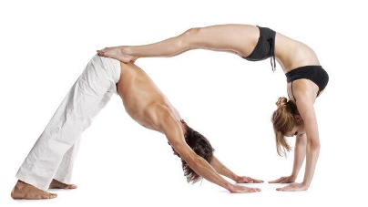 | 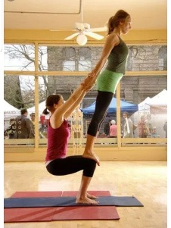
 | Dance around the mat | Dance around the mat | Dance around the mat | Dance around the mat
 | Mtn to Goddess | Mtn to WII | Mtn to Goddess | Mtn to WII
 | Skandasana | Pyramid | Skandasana | Pyramid
 | Low Lunge to Lizard | Triangle | Lizard to Flying Lizard | Triangle
 | 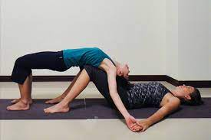 | 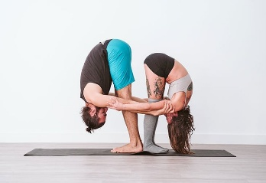 |  | 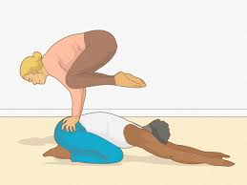
 | Dance around the mat | Dance around the mat | Dance around the mat | Dance around the mat

